

**CS103L Circuit And System**

**Department of Computer System Engineering**

**University of Engineering and Technology Peshawar**

Submitted to: **Engr. Faiz Ullah**

Submitted by: **Muhammad Saad**

ETEA ID: **50804**

**DCSE, Batch 23, Section “B”**



Student Signature: ____________

**Lab Report No 9 & 10:**

**Thevenin’s and Norton’s theorem using PSPICE**

**ASSESSMENT RUBRICS LAB # 9 & 10**

**Thevenin’s and Norton’s theorem using PSpice**

|  |  |  |
| --- | --- | --- |
| **Criteria** | **Excellent** | **Marks Obtained** |
| 1. **Objectives of Lab** | All objectives of lab are properly covered  [Marks 0.5] |  |
| 1. **Thevenin and Norton’s Theorem** | Brief introduction to both the theorems and circuit diagrams and mention “ab” terminal points.  [Marks 1.5] |  |
| 1. **PSpice** | Brief introduction and steps for simulation  [Marks 2] |  |
| 1. **Observations and calculations** | Each step to obtain final result along with circuit diagrams  [Marks 5] |  |
| 1. **Conclusion** | Conclusion obtained from readings  [Marks 1] |  |

**Lab no 9 & 10: Thevenin’s and Norton’s theorem using PSPICE**

**Objective:**

* To verify Thevenin’s and Norton’s theorem using PSPICE

**Apparatus:**

Computer with PSPICE installed on it.

**PSPICE Simulator:**

PICE stands for Stimulated Program for Integrated Circuit Emphasis. It is a general-purpose analogue circuit simulator and is used to verify circuit designs and also to predict the circuit behaviour. PSPICE is the PC version of PSPICE.

**Procedure:**

1. First, we have to open schematics in PSPICE software.
2. We have to click on “Get New Parts” place 8 resistors by searching for “r”.
3. Then we search “vdc” and place one voltage source.
4. We also need a ground source for which we search “gnd-earth” and place one.
5. Then we arrange the components as following and connect the circuit elements with the help of a wire.
6. After that by clicking on simulate all the result are shown.

**Thevenin’s and Norton’s theorem:**

Thevenin’s theorem helps in solving complex circuit easily. In Thevenin’s theorem we find voltage across a specific resistor. We do that by excluding the resistor from the circuit and leave the circuit open. Then we find the voltage across the open part of the circuit. This voltage is known as Thevenin’s voltage *VTH*. Then we short circuit that part and find the current *ISC*. With *VTH* and *ISC*  we can find Thevenin’s resistance *RTH*. By suing *RTH* and *VTH* we find Norton current later.

**Observations and Calculations:**

Below is the circuit in which we find the voltage across 25Ω resistor.

VORG = 6.028V & IORG = 241.10mA

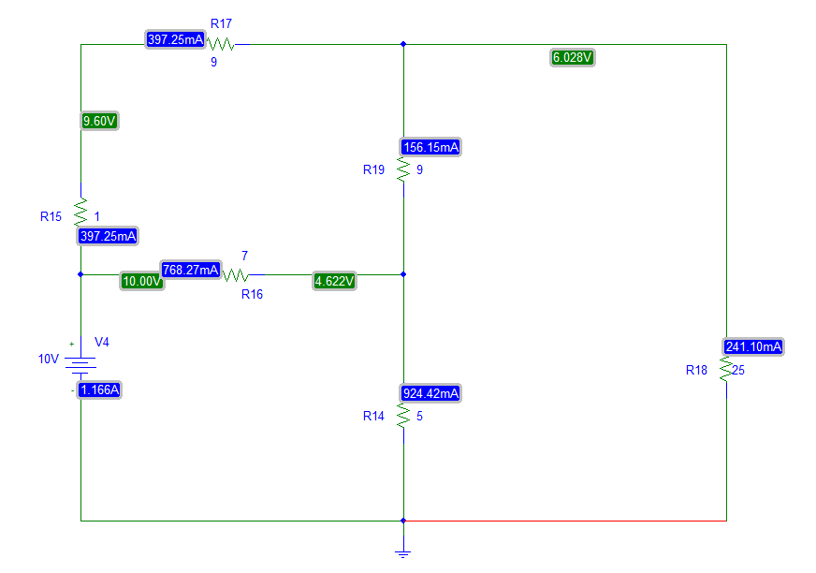

Original Circuit fig.01

First, we remove that resistor and leave the circuit open. The current will stop flowing through that part but voltage will still be there. That voltage is known as Thevenin’s Voltage VTH.

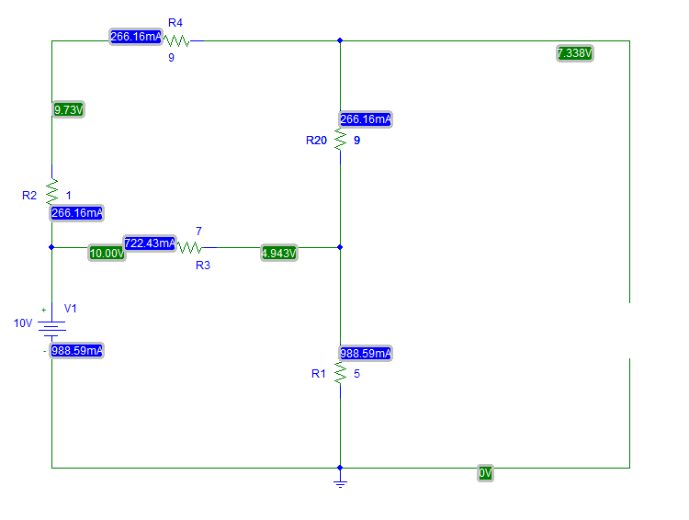

Resistor 25Ω removed fig.02

Here

VTH= 7.338V

After this we have to find the ISC for which we have short circuit the 25Ω part and note the current with the help of “IPROBE” in PSPICE.

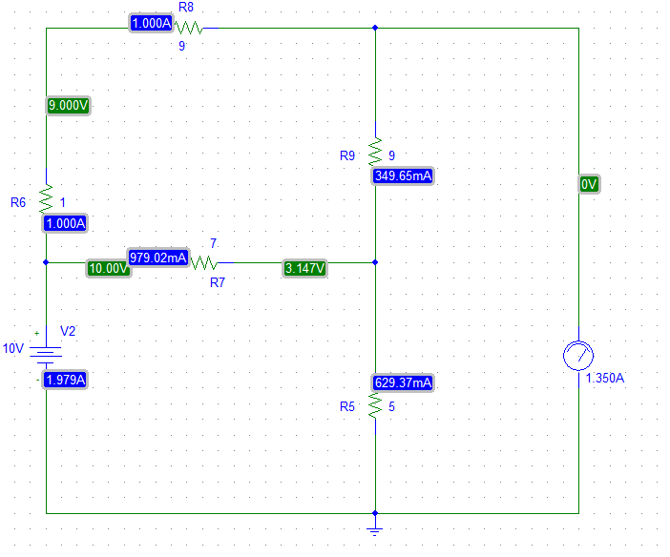

Shot circuited circuit fig.03

ISC = 1.350A

Now that VTH and ISC are know we can easily find the Thevenin’s resistance as follow.

RTH =

RTH =

RTH = 5.4355Ω

In = =

In = 1.350

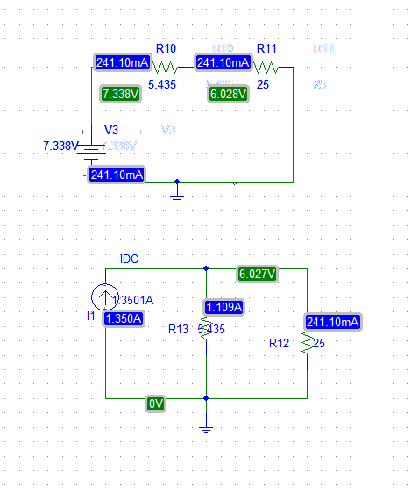Now we can make a Thevenin’s equivalent circuit as follow.

Thevenin’s Equivalent Circuit fig.04

Therefore, the voltage across the 25Ω resistor and current are the same as they were in the original circuit.

V= VORG = 6.028V

At the end we transform the Thevenin’s equivalent circuit by source transformation as follow.

Source Transformation fig.05

In the above circuit In is Norton’s current which we found earlier. So this is Thevenin’s and Norton’s theorem.

So, the goal was to verify the voltage drop across the 25Ω resistor which was 6.028 Volts. It was equal in the original circuit and Thevenin’s equivalent circuit and Norton’s equivalent circuit, thus verifying the Thevenin’s and Norton’s theorem.

**Conclusion:**

Thevenin’s and Norton’s theorem is an easier method to calculate the voltage drop across a load. With other method where we had to calculate voltage at every node of the circuit was very difficult and time consuming as compared to this theorem.